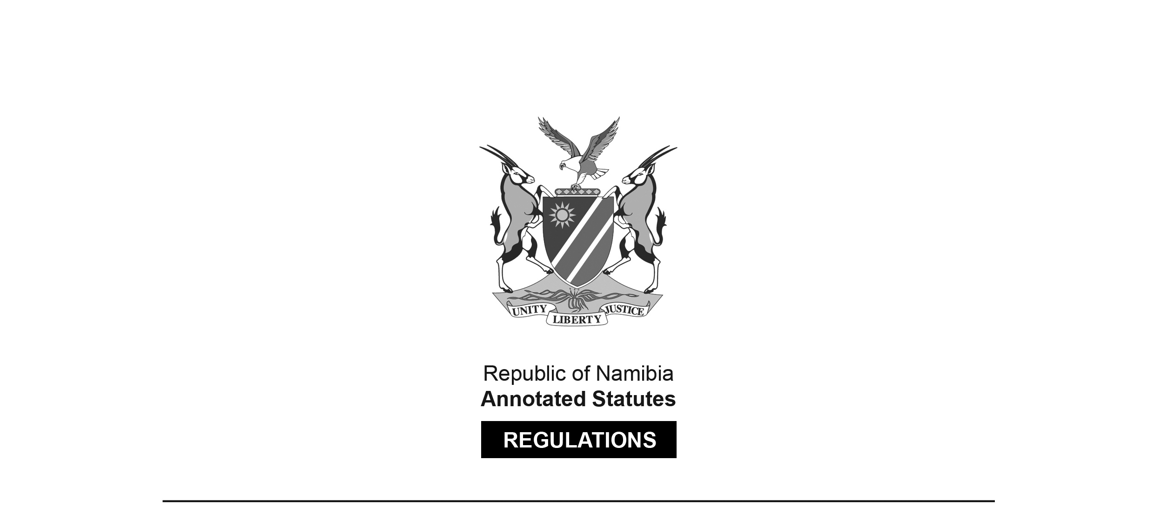

REGULATIONS SURVIVING IN TERMS OF

Health Professions Act 16 of 2024

section 95(10)

Regulations relating to Scope of Practice of  
Medical Orthotist and Prosthetist

Government Notice 129 of 2022

([GG 7794](http://www.lac.org.na/laws/2022/7794.pdf))

came into force on date of publication: 27 April 2022

These regulations were made in terms of section 55 of the Allied Health Professions Act 7 of 2004, which was repealed by the Health Professions Act 16 of 2024. Pursuant to section 95(10) of the Health Professions Act 16 of 2024, they are deemed to have been made under that Act.

The Government Notice which publishes these regulations notes that they were made on the recommendation of the Allied Health Professions Council of Namibia.

ARRANGEMENT OF REGULATIONS

1. Definitions

2. Scope of practice of medical orthotist and prosthetist

**Definitions**

**1.** In these regulations a word or an expression to which a meaning has been assigned in the Act has that meaning and, unless the context otherwise indicates -

“medical device” means a medical device as defined in the Medicines and Related Substances Control Act, 2003 (Act No. 13 of 2003);

“practitioner” means a practitioner as defined in section 1 of the Hospital and Health Facilities Act, 1994 (Act No. 36 of 1994); and

“the Act” means the Allied Health Professions Act, 2004 (Act No. 7 of 2004).

[The Allied Health Professions Act 7 of 2004 has been   
replaced by the Health Professions Act 16 of 2024.]

**Scope of practice of medical orthotist and prosthetist**

**2.** (1) A medical orthotist and prosthetist is a practitioner who is specifically educated and trained to manage comprehensive orthotic or prosthetic patient care.

(2) Subject to subregulation (1) the following acts fall within the scope of practice of a medical orthotist and prosthetist -

(a) patient assessment;

(b) formulation of a treatment plan;

(c) implementation of the treatment plan;

(d) follow-up and practice management; and

(e) establishing medical necessity for orthotic or prosthetic care.

(3) A medical orthotist and prosthetist when conducting a patient assessment must -

(a) in a patient with impairment of human movement or musculoskeletal abnormalities that would impede the ability of the patient to participate in social or work environment or other activities to determine a functional intervention;

[The introductory phrase does not fit together with paragraph (a)   
in terms of sentence structure. It is not clear what was intended.]

(b) include but is not limited to the evaluation and documentation of -

(i) anthropometric data;

(ii) cognition (visual perception of the patient);

(iii) range of motion;

(iv) muscle strength;

(v) skin integrity;

(vi) pain on the body part being assessed;

(vii) central and peripheral nerve integrity;

(viii) gait analysis including temporal and spatial assessment; and

(ix) orthotic or prosthetic requirements of the patient based on the diagnosis.

(4) A medical orthotist and prosthetist in formulating a treatment plan must -

(a) base the plan on a comprehensive assessment to design an intervention, alleviate limitations, improve function and enhance quality of life;

(b) include, but is not limited to -

(i) verifying of prescription or documentation;

(ii) evaluating of the prescription rationale;

(iii) formulating of detailed technical prescription;

(iv) needs assessment based on patient and caregiver input;

(v) developing of functional goals;

(vi) using of evidence-based practice;

(vii) analysing of structural and design requirements; and

(viii) consulting with, or referral to other practitioners.

[There should be a comma after the phrase “or referral to”, to offset that phrase properly.]

(5) A medical orthotist and prosthetist in implementing the orthotic or prosthetic treatment plan must include, but is not limited to -

(a) acquisition of anthropometric data;

(b) modifying and rectifying of anthropometric data;

(c) preparing for care;

(d) appropriate material selection;

(e) fabricating of orthoses or prostheses;

(f) supervising of the provision of care;

(g) developing prototype evaluative wear;

(h) diagnostic fitting;

(i) assessment of intervention;

(j) gait training;

(k) functional training (both self-care and work related);

(l) patient education and instruction; and

(m) documentation of patient encounter.

(6) A medical orthotist and prosthetist must utilise a follow-up treatment plan that ensures successful orthotic or prosthetic outcomes which includes, but is not limited to -

(a) documentation of patient encounters, including functional changes;

(b) progress in meeting goals and expected outcomes;

(c) formulation of modifications to ensure successful outcomes;

(d) reassessment of patient goals;

(e) reassessment of treatment objectives;

(f) development of long-term treatment plan; and

(g) confirmation of patient education and instruction.

(7) A medical orthotist and prosthetist must promote competency and enhancement of orthotic or prosthetic professional practice to contribute to the body of knowledge of the profession this includes, but is not limited to participation in -

(a) continuing education;

(b) training of residents or students;

(c) clinical research;

(d) evidence-based studies;

(e) promotion of public awareness of the orthotic or prosthetic profession; and

(f) consumer organisations, governmental and non-governmental organisations.